**PYTHON ASSIGNMENT – 2**

**Q1. What should be the output? ( 3 + 4 ** 6 - 9 * 10 / 2 )**

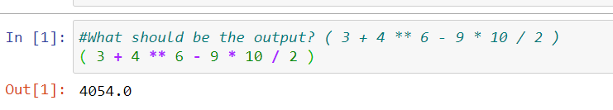

**Q2. Let say I have, some string "hello this side regex"**

* **Find out the count of the total vowels**
* **vowels - ['a','e','i','o','u']**

Count of each vowel.

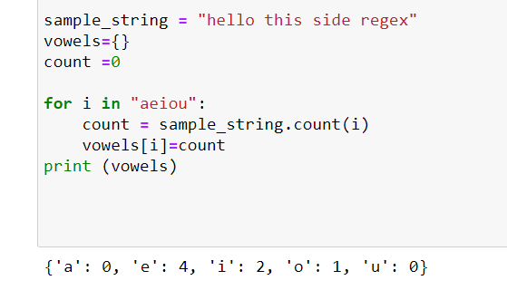

Sum of count of all vowels.

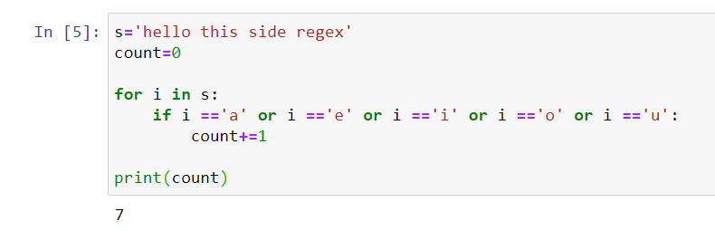

**Q3.** **Find out the area of triangle**

* **1/2 * b * h (formula of area)**
* **You have to take value from user about the base, & the height**

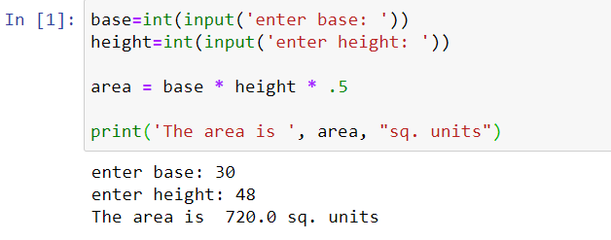

**Q4. Take input of year from user and print the calendar of the year.**

